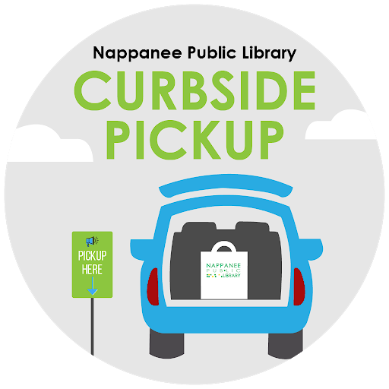

Reserved
For
Curbside
Pickup
244-5541

- You must receive notice you have “Hold” items available for pickup.
- You or the person designated to pick up your holds must present your library card. A digital form of library card is acceptable.
- If you are picking up holds for someone other than yourself, you must be designated on that person’s account and have your photo ID.
- Pickup times will be available during the following hours:
  - Monday: 9-5:30
  - Tuesday: 9-7:30
  - Wednesday: 9-7:30
  - Thursday: 9-7:30
  - Friday: 9-5:30

- Your account must be in good standing (i.e. not blocked due to over the limit fines or over the limit items.)
- Payments on accounts will not be accepted at curbside. Payments may be made online through My Account at www.ppl.lib.in.us or at the circulation desk during business hours.
- Items may be returned in disposable plastic shopping bags. Loose items must be returned in either the drive-up drop box or the drop box located at our entrance.

Curbside Pickup Step-by-Step

Step 1: Place holds online @ www.ppl.lib.in.us or call the library @ (260) 244-5541. All available items placed on hold by 12 noon should be available for pickup the same day.
Step 2: Once you receive notice you have items available, come to the library during our pickup hours, park in one of our designated spots and call (260) 244-5541.You will be asked for your name and library card number.
Step 3: Have your library card ready and a staff member will bring your items out in a few minutes. If picking up items for others you will also be asked to show your photo ID.
Please let us know when you call if you need B.A.B.E coupons!

